Problem Statement
UC: What preventive action to take to save data in case of laptop crash?
take backup outside the laptop
(External storage), external system, either your VM or may be external storage.

Why logs? identify the issue
Running process generates some data e.g., logs, stores with in container
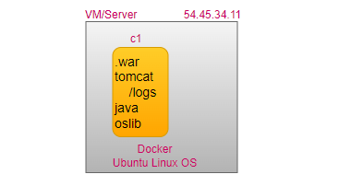
UC: If we lose the container, we lose the data
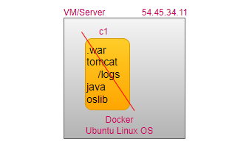
It is not a good practice to write data inside a container
UC: If there is any issue in your application, where you troubleshoot issue?
logs, where are these logs? Inside the container.
If I remove the container, can I get log back?
No, whatever data inside the container will be lost.
docker container ls # list of all running containers
docker container ls -a # list of all containers
docker container ls -aq # list of all stopped container
# docker ps -aq --no-trunc -f status=exited | xargs docker rm
#docker rm -f ‘docker ps -aq’ # delete all containers
docker ps
docker run -d tomcat # default is latest tag

docker build -f Dockerfile --tag sampleapp:v2 /root # in which directory Dockerfile available
docker run -d –P sampleapp:v3

docker exec -it <CONTAINERID> /bin/bash
cd /opt/tomcat
ls -l
cd logs/
ls -l
exit
docker rm -f <CONTAINERID> # can we get the log /recover the data
Solution: docker volume
Rather than writing data inside the container, write the data into NAS/SAN
NAS: Network attached Storage
SAN: Storage Area Network
Docker Volume just like external storage, helps to make data persistent
Volume (Storage Drive)-persistent outside the container
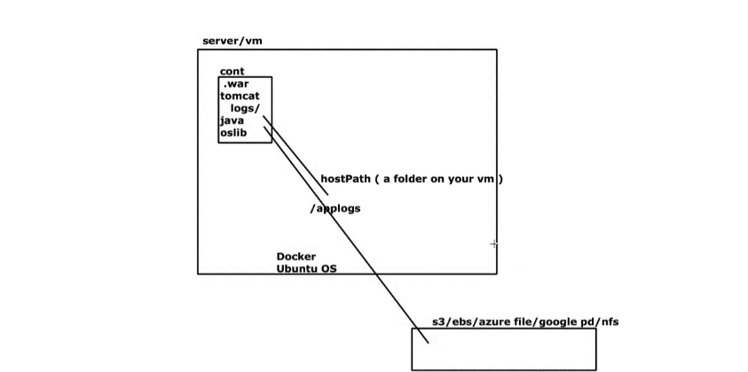

docker volume ls
docker volume create applogs
docker volume inspect # /var/lib/docker/volumes/applogs/-data
cd /var/lib/docker/volumes/applogs/-data
ls-l # nothing is here
We can’t attach a volume to existing running container, attach volume while creating a container
docker build -f myapp --tag myapp:v2 /root # in which directory Dockerfile available
docker run -d -P --mount type=volume,src=applogs,target=/opt/tomcat/logs myapp:v1
# Binds the container path with target with local host path with src
docker ps
cd /var/lib/docker/volumes/applogs/-data
ls -l # data is persistent
docker rm -f <CONTAINERID> # can we get the log /recover the data 😊

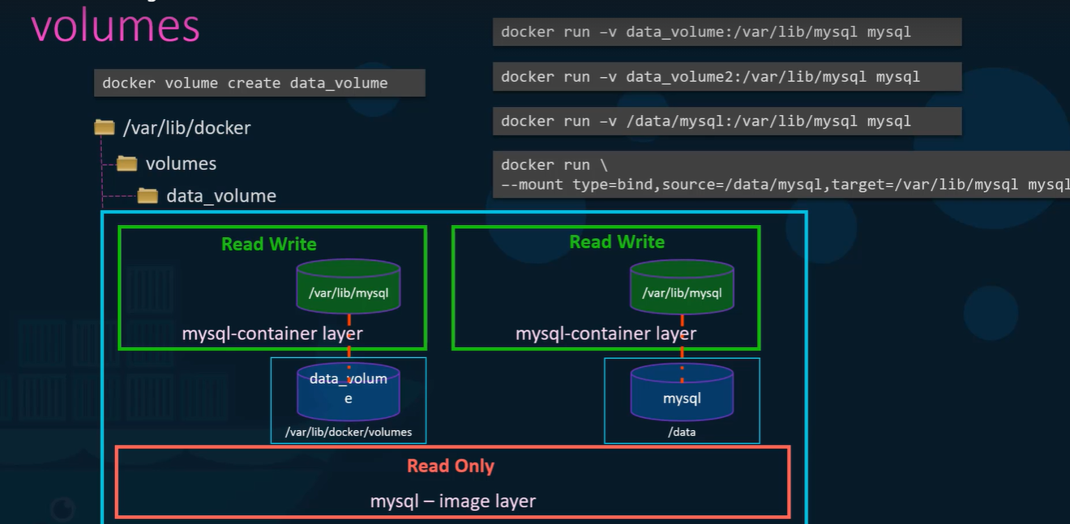
Concept of docker volume is to keep the data outside the container.
docker rm -f ‘docker ps -qa’ # remove all containers
step1: where are the container logs available?
UC1: Create Container without volumes
docker run -d -P sampleapp: v3
docker ps
docker exec -it <container id> bash
cd /opt/tomcat/logs
ls -l
ctrl pq
docker rm -f <container id>
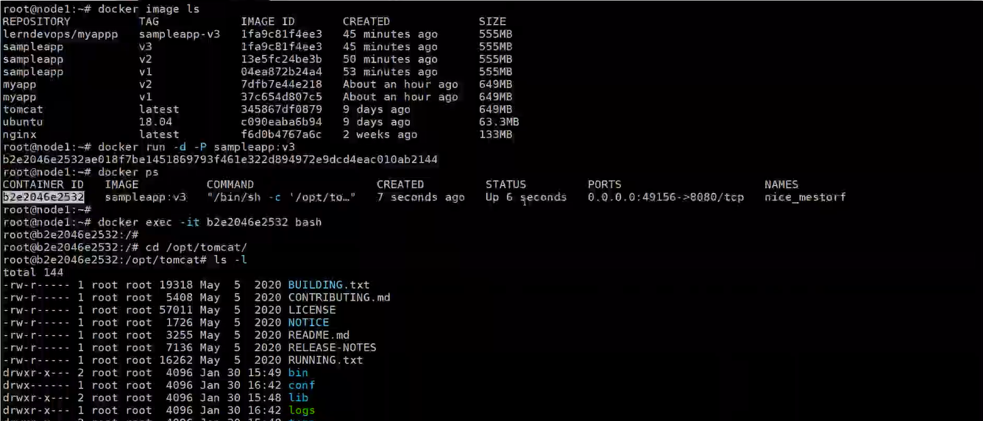
log file is inside the container, if we remove the container, logs will also lost.
UC2: Create Container with volumes
docker volume ls
docker volume create myvol # local volume
docker volume ls
docker volume inspect myvol # /var/lib/docker/volumes/myvol/_data
docker run -d -P --volume myvol:/opt/tomcat/logs sampleapp: v3
cd /var/lib/docker/volumes/myvol/_data
ls -l
For existing container, we can’t attach a volume, volume can be attached during container creation time.
UC3: custom location (bind mount)
mkdir nginxconfig
mkdir nginxlogs
docker run -d -P --mount type=bind,src=/root/nginxconf,target=/usr/share/nginx/html --mount type=bind,src=/root/nginxlogs,target=/var/log/nginx nginx:latest
docker volume ls
docker volume create myvol # local volume
docker volume ls
docker volume inspect <Id>
cd /var/lib/docker/volumes/myvol/_data
ls -l # no data
docker run -d -P --volume myvol:/opt/tomcat/logs sampleapp:v3 # local host: <container path>
cd /var/lib/docker/volumes/myvol/_data
touch neeraj.txt
docker exec -it <containerid > bash
cd /opt/tomcat/logs
ls -l
touch vohra.txt
exit
cd /var/lib/docker/volumes/myvol/_data
ls -l

customized path: bind mount
mkdir /logs
mkdir /config
docker run -d -P --volume /logs:/var/log/nginx --volume /config: /usr/share/nginx/html nginx
cd /logs
ls -l
cd /config
ls-l
touch index.html
echo "My Nginx Container" > index.html
ls -l
cd /logs
tail -f access.log

docker run -d -P --mount type=bind,source=/config,target=/usr/share/nginx/html nginx #dst
docker run -d -P --mount type=volume,source=myvol,target=/usr/share/nginx/html nginx #dst
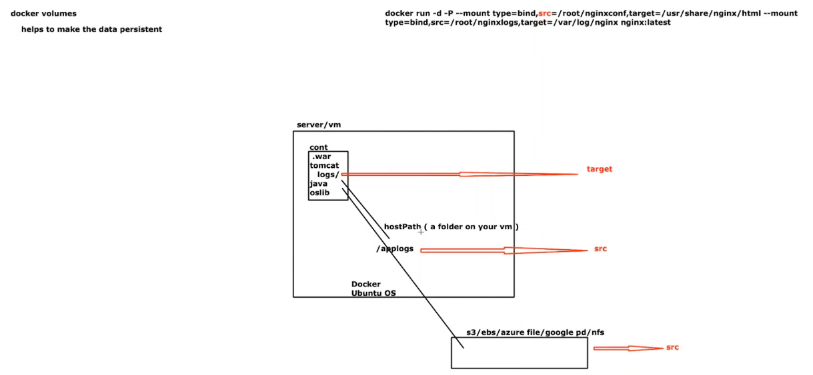

What if data is in different server?
We have to keep data is central location like S3.
